Project Report CIS 305- Group Project

Chipotle Restaurants Inc. Database

**Group members for KAL Consulting Group: Bryan Kim, Adolfo Alarcon, Brian Lugo**

**Business problem description:**

Relevant background: Chipotle is a non-franchised quick service restaurant, with over 2,000 stores within the continental Unites States. They offer non-GMO food products, in order to provide healthy and organic food to its customers, for a profit. Chipotle is known for the great integrity of their food quality and fresh ingredients with a strong commitment to food safety.

Practical problem: Chipotle is having difficulty with its current supply chain database, and with the ability to track the orders are being placed on time by employees, and if the contracted shippers have been delivering to stores on time. Their current system has left many restaurants having shortages on food ingredients, which has caused them to lose on potential revenue and is leaving many customers dissatisfied.

Solution to problem: This business problem has left Chipotle Inc. to contract the services of KAL Consulting Group, with the hope that the group will be able to implement a new database system. This new system will aim to create an efficient system to track when, and which employees place store orders and if the shippers are sending deliveries to stores on time. Furthermore, the new database will improve Chipotle’s ability to view potential points of error in its current ordering system

**ER Diagram**

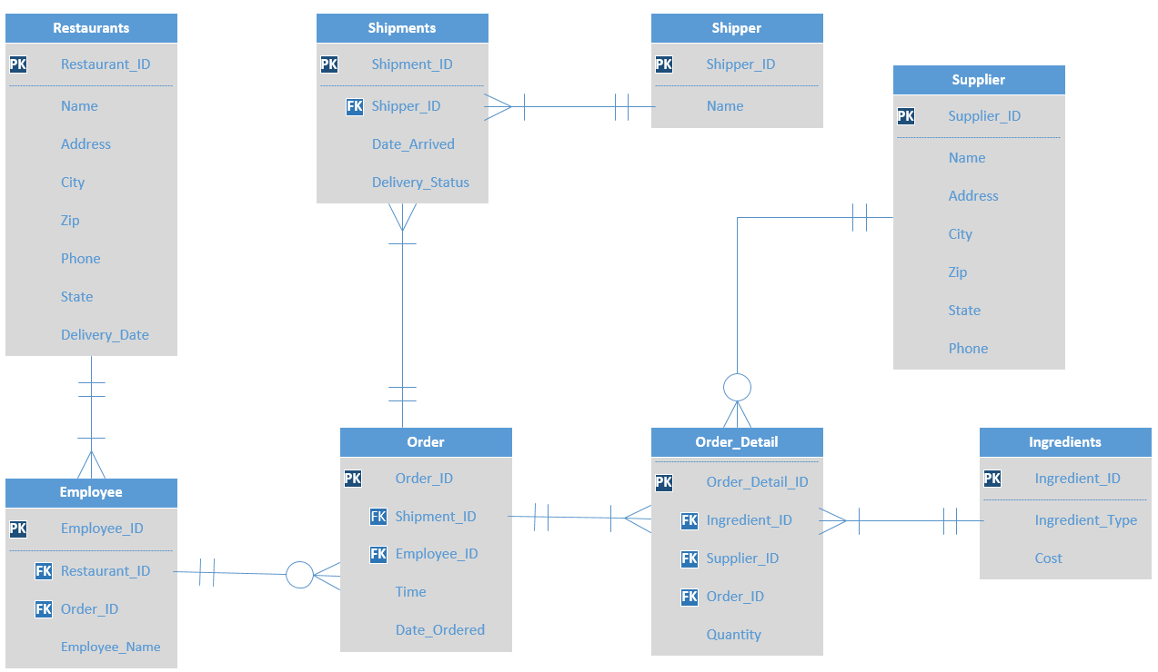

**Business Rules**

**Restaurants to Employee**

1. A Chipotle restaurant must employ at least one employee, and can have up to many different employees.
2. An employee can work for one and only one Chipotle restaurant.

**Employee to Order**

1. One employee can place no orders, and can place very many orders.
2. One order may be placed by one and only one employee at a time.

**Order to Shipments**

1. One order must include at least one to many shipments
2. A shipment must belong to one and only one order

**Shipments to Shipper**

1. One shipment can be sent by one and only one shipper.
2. A shipper can send no shipments, and can send very many different shipments.

**Order to Order Detail**

1. An order must include at least one order detail but may have up to many order details.
2. One order detail can be included on one and only one order at time.

**Ingredients to Order Detail**

1. At least one to many ingredients must be included on an order detail
2. An order detail must include one and only one ingredient

**Supplier to Order Detail**

1. A supplier can fulfill no order details, or can fulfill many different order details
2. One order detail must be fulfilled by one and only one supplier

**Logical Design (Relational Schema)**

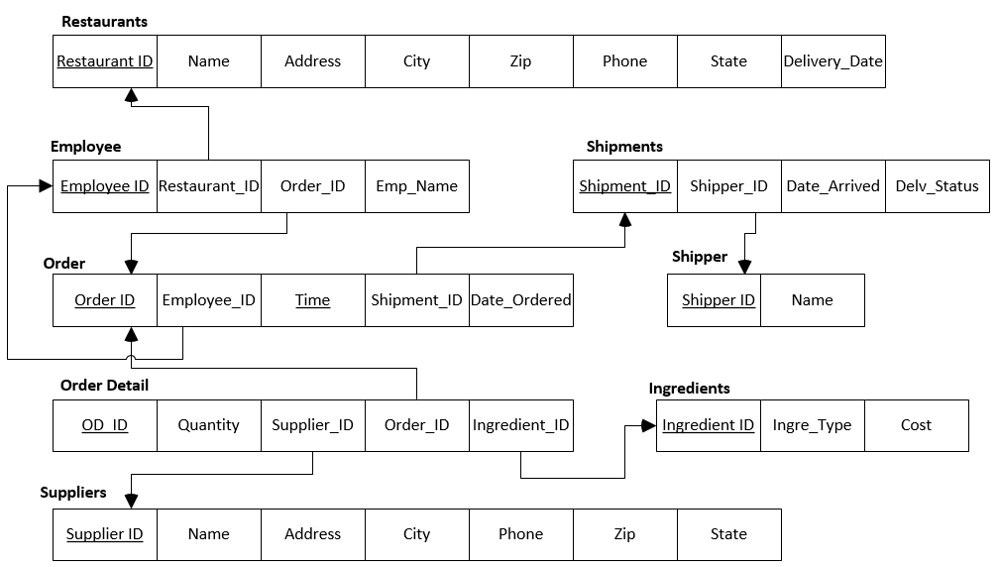

**Implementation**

Restaurants

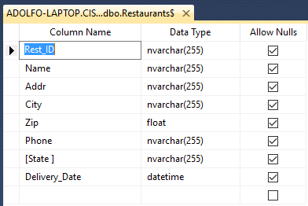

Employees

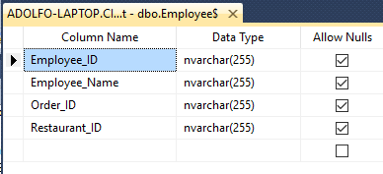

Order

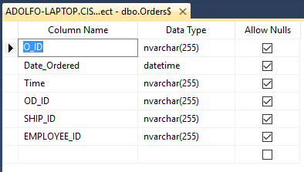

Order Details

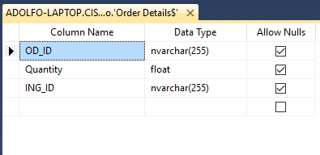

Supplier

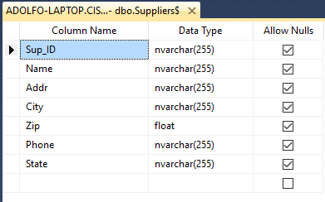

Shippers

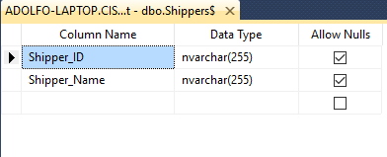

Shipments

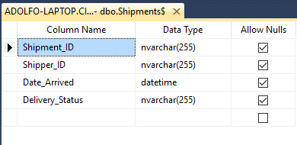

Ingredients

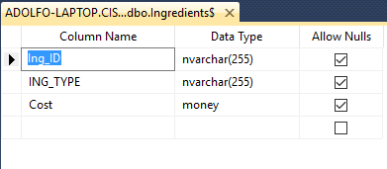

Employee



**Relationship (database) diagram in SQL Server**

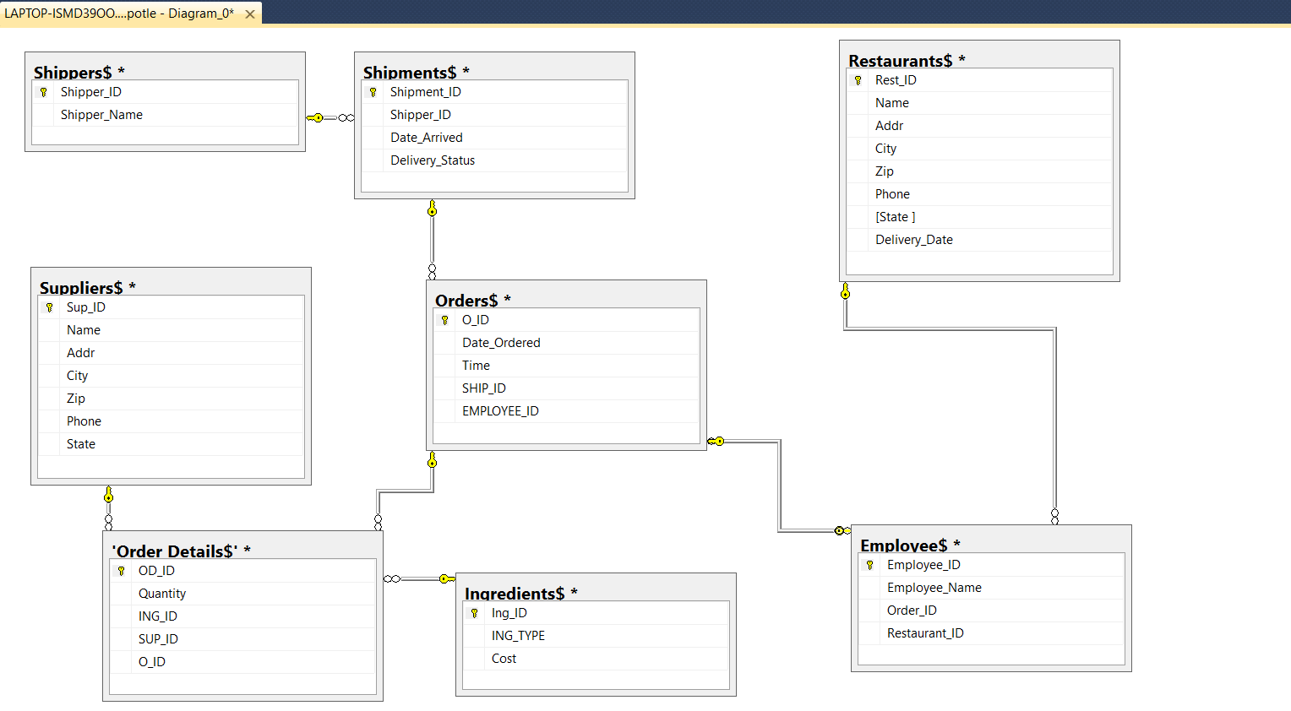

SQL Statements

**Which orders were on time?**

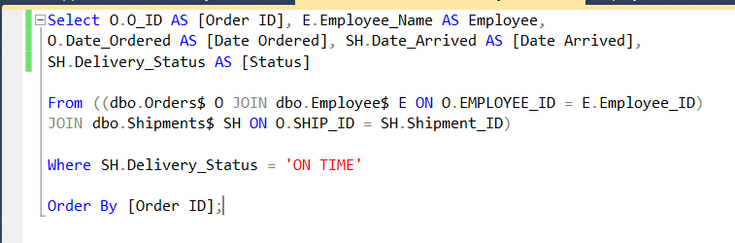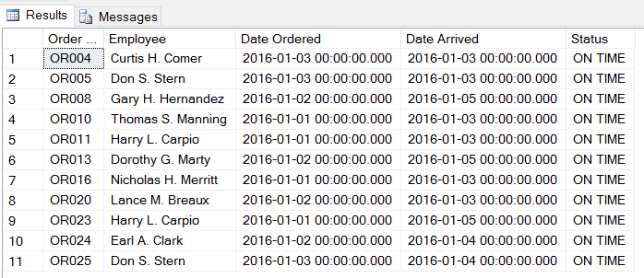

**What percentage of orders were late?**

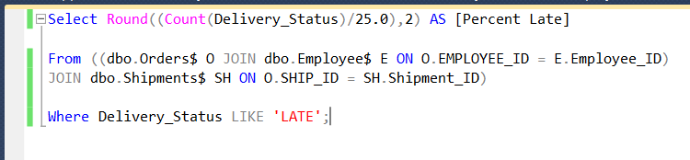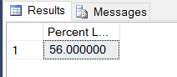

**Which employees and shippers had late order?** 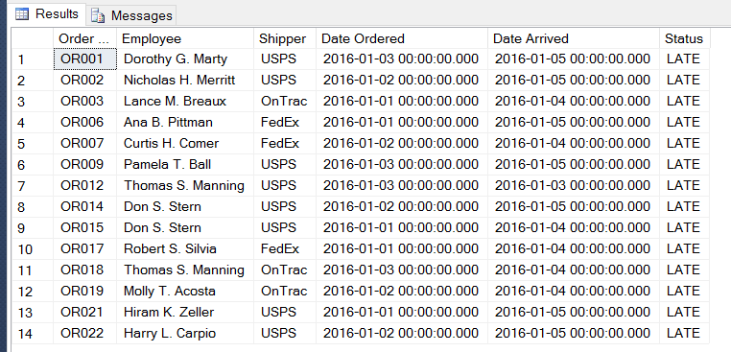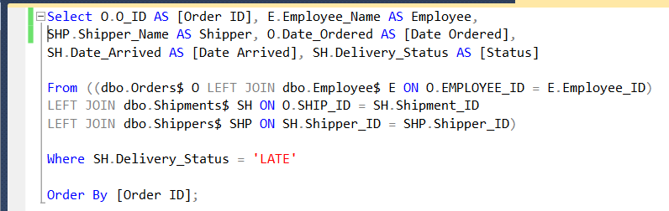

**How many late orders did employees have?** 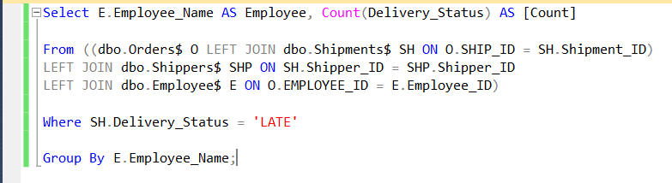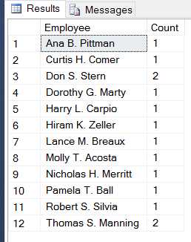

**How many late orders exceeded or equaled 10% of total orders by shippers?**

